MODULE III
3.1 THE GREEDY METHOD – CONTROL ABSTRACTION
The greedy method suggests that one can devise an algorithm that works in stages, considering one input at a time. At each stage, a decision is made regarding whether a particular input is in an optimal solution. This is done by considering the inputs in an order determined by some selection procedure. If the inclusion of the next input into the partially constructed optimal solution will result in an infeasible solution, then this input is not assed to the partial solution. Otherwise, it is added. The selection procedure itself is based on some optimization measure. The measure may be the objective function. In fact, several different optimization measures may be plausible for a given problem. Most of these, however, will result in algorithms that generate suboptimal solutions. This version of the greedy technique is called the subset paradigm.
The function Select selects an input from a[ ] and removes it. The selected input’s value is assigned to x. Feasible is a Boolean-valued function that determines whether x can be included into the solution vector. The function Union combines x with the solution and updates the objective function. The function Greedy describes the essential way that a greedy algorithm will look, once a particular problem is chosen and the functions Select, Feasible, and Union are properly implemented.
Algorithm Greedy (a,n)
//a[1 : n] contains the n inputs.
{ Solution :=ø;// Initialize the solution.
for i:=1 to n do
{ x:=Select(a);
if Fesible(solution,x) then
solution := Union(solution,x);
}
return solution;
}
3.1.1 GENERAL KAPSACK PROBLEM
In the knapsack problem, we have n objects and a knapsack or a bag. Object i has a weight wi and the knapsack has a capacity m. If a fraction xi, 0 ≤ xi ≤ 1, of object i is placed into the knapsack, then a profit of pixi is earned. The objective is to obtain a filling of the knapsack that maximizes the total profit earned. Since the knapsack capacity is m, we require the total weight of all chosen objects to be at most m. Formally, the problem can be stated as
maximize ∑ pixi
1≤ i≤n

Subject to ∑ wixi ≤ m
1≤i≤ n

And 0 ≤ xi ≤ 1, 1 ≤ i ≤ n
The profit and weight are positive numbers. This is done by using greedy method.

ALGORITHM
ALGORITHM greedyknapsack(m, n )
/ / p[ 1.. n] , w[ 1.. n]
/ / pi/ wi ≥ pi+1/ wi+1
/ / x[1 …. n] solution
{
for i=1 to n do
x[1] =0.0 ;
u=m ;
for i= 1 to n do
{
If ( w[i] > u) then break ;
x[i] = 1.0 ;
u = u – w[i] ;
}
If ( i ≤ n ) then x[i] = u/ w[i] ;
}

If p1 / w1 ≥ p2 /w2 ≥ ……………. ≥ pn / wn , then greedy knapsack generate an Optimum solution to the given instant of knapsack problem. All optimum solutions will fill the knapsack exactly complexity of knapsack algorithm is 0( n).
Greedy algorithms
Similarly to dynamic programming, greedy algorithms are used to solve optimization problems. In contrast to dynamic programming, no global optimal solution is computed, but rather locally optimal decisions are taken. That is why the approach is called greedy.
Example: Knapsack Problem I
2 possible greedy-strategies: select the most valuable element in each step that still fits into the knapsack: Knapsack capacity: 15

Object Size Value
g1 3 3
g2 4 5
g3 6 8
g4 7 9
choose: g4; value: 9;
remaining capacity: 8
choose: g4; value: 9;
remaining capacity: 1
y not optimal

Example: Knapsack Problem II
Select the relatively most valuable element (max (v (gi) s (gi)))
This will lead to the optimal solution in the case described above. However, this need not always be the case!
Knapsack capacity: 50
Object Size Value vs.
g1 30 90 3
g2 40 100 2, 5
g3 50 110 2, 2
The strategy will choose
g1 (value 90).
However, the optimal would be g3 (value 110) Greedy algorithms do not always provide the optimal solution. In exchange, they are far less expensive than dynamic programming. Complexity of the greedy-knapsack: O(C)
3.1.2 OPTIMAL STORAGE ON TAPES
Optimal storage on tapes I
Given: n programs P1, . . . , Pn with lengths l1, . . . , ln.
The programs are stored on a tape in order Pi1 , . . . , Pin .
Time to access Program Pij :
T(i1, . . . , in, j) = li1 + · · · + lij .
Average access time:
T(i1, . . . , in) = 1n
Xn
j=1
T(i1, . . . , in, j)= 1n
Xn
j=1
Xj
i=1
lij= 1n
Xn
j=1
(n − j + 1)lij
Optimal storage on tapes II
How to store the programs on the tape so that the average access time becomes minimal?
Let n be fixed; hence 1n can be ignored.
Example: Let P1, P2, P3 have lengths 17, 5, 10.
order acess time
P1P2P3 17 + (17 + 5) + (17 + 5 + 10) = 71
P1P3P2 17 + (17 + 10) + (17 + 10 + 5) = 76
P2P1P3 59
P3P1P2 69
P2P3P1 52
P3P2P1 52

Optimal storage on tapes III
Fact:
If for the lengths l1, . . . , ln the relation l1 _ l2 _ · · · _ ln holds, then the average access time is minimized by the order P1 . . . Pn. Hence, a greedy strategy that always selects the shortest program leads to the minimal average access time.
What have we learnt on greedy algorithms?
Greedy algorithms treat optimization problems by taking locally optimal decisions. Hence, they may fail to determine the global optimum. Greedy algorithms need less time than, e.g., dynamic programming. There are problems where a greedy strategy leads to an optimal solution.

3.2 MINIMUM SPANNING TREE
- Let G(V,E) be an undirected connected graph with vertices ‘v’ and edge ‘E’.
- A sub-graph t=(V,E’) of the G is a Spanning tree of G iff ‘t’ is a tree.3
- The problem is to generate a graph G’= (V,E) where ‘E’ is the subset of E,G’ is a Minimum spanning tree.
- Each and every edge will contain the given non-negative length .connect all the nodes with edge present in set E’ and weight has to be minimum.
NOTE:
- We have to visit all the nodes.
- The subset tree (i.e) any connected graph with ‘N’ vertices must have at least N-1 edges and also it does not form a cycle.
Definition:
- A spanning tree of a graph is an undirected tree consisting of only those edge that are necessary to connect all the vertices in the original graph.
- A Spanning tree has a property that for any pair of vertices there exist only one path between them and the insertion of an edge to a spanning tree form a unique cycle.
Application of the spanning tree:
1. Analysis of electrical circuit.
2. Shortest route problems.

Minimum cost spanning tree:
- The cost of a spanning tree is the sum of cost of the edges in that tree.
- There are 2 method to determine a minimum cost spanning tree are
1. Kruskal’s Algorithm
2. Prom’s Algorithm.
3.2.1 KRUSKAL’S ALGORITHM:
In kruskal's algorithm the selection function chooses edges in increasing order of length without worrying too much about their connection to previously chosen edges, except that never to form a cycle. The result is a forest of trees that grows until all the trees in a forest (all the components) merge in a single tree.
- In this algorithm, a minimum cost-spanning tree ‘T’ is built edge by edge.
- Edges are considered for inclusion in ‘T’ in increasing order of their cost.
- An edge is included in ‘T’ if it doesn’t form a cycle with edge already in T.
- To find the minimum cost spanning tree the edge are inserted to tree in increasing order of their cost
Algorithm:
Algorithm kruskal(E,cost,n,t)
//E→set of edges in G has ‘n’ vertices.
//cost[u,v]→cost of edge (u,v).t→set of edge in minimum cost spanning tree
// the first cost is returned.
{
for i=1 to n do parent[I]=-1;
I=0;mincost=0.0;
While((I<n-1)and (heap not empty)) do
{
j=find(n);
k=find(v);
if(j not equal k) than
{
i=i+1
t[i,1]=u;
t[i,2]=v;
mincost=mincost+cost[u,v];
union(j,k);
}
}
if(i notequal n-1) then write(“No spanning tree”)
else return minimum cost;
}
Analysis
- The time complexity of minimum cost spanning tree algorithm in worst case is O(|E|log|E|),
→ where E is the edge set of G.

Example: Step by Step operation of Kurskal algorithm.
Step 1. In the graph, the Edge (g, h) is shortest. Either vertex g or vertex h could be representative. Let’s choose vertex g arbitrarily.
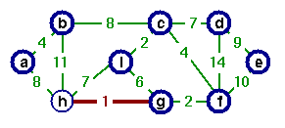
Step 2. The edge (c, i) creates the second tree. Choose vertex c as representative for
second tree
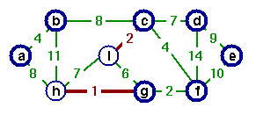
Step 3. Edge (g, g) is the next shortest edge. Add this edge and choose vertex g as representative.
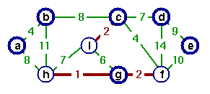
Step 4. Edge (a, b) creates a third tree.
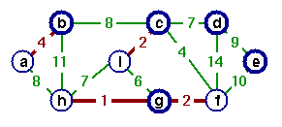
Step 5. Add edge (c, f) and merge two trees. Vertex c is chosen as the representative.
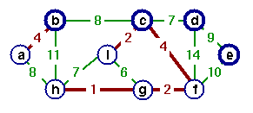
Step 6. Edge (g, i) is the next cheapest, but if we add this edge a cycle would be created. Vertex c is the representative of both.
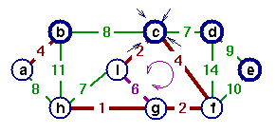
Step 7. Instead, add edge (c, d).
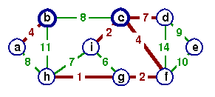
Step 8. If we add edge (h, i), edge(h, i) would make a cycle.
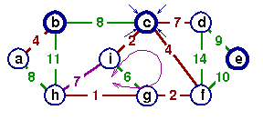
Step 9. Instead of adding edge (h, i) add edge (a, h).
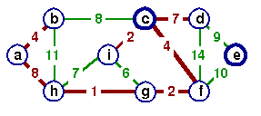
Step 10. Again, if we add edge (b, c), it would create a cycle. Add edge (d, e) instead to complete the spanning tree. In this spanning tree all trees joined and vertex c is a sole representative.
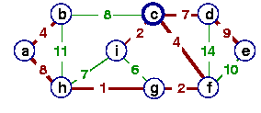

3.2.2 Prim's Algorithm
Start from an arbitrary vertex (root). At each stage, add a new branch (edge) to the tree already constructed; the algorithm halts when all the vertices in the graph have been reached.
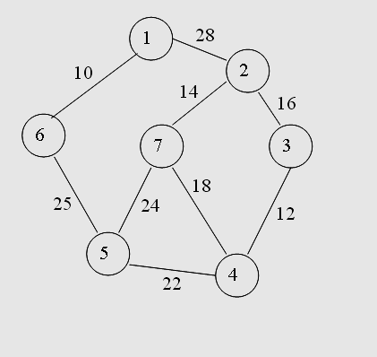
Algorithm prims(e,cost,n,t)
{
Let (k,l) be an edge of minimum cost in E;
Mincost :=cost[k,l];
T[1,1]:=k; t[1,2]:=l;
For I:=1 to n do
If (cost[i,l]<cost[i,k]) then near[i]:=l;
Else near[i]:=k;
Near[k]:=near[l]:=0;
For i:=2 to n-1 do
{
Let j be an index such that near[j]≠0 and
Cost[j,near[j]] is minimum;
T[i,1]:=j; t[i,2]:=near[j];
Mincost:=mincost+ Cost[j,near[j]];
Near[j]:=0;
For k:=0 to n do
If near((near[k]≠0) and (Cost[k,near[k]]>cost[k,j])) then
Near[k]:=j;
}
Return mincost;
}
- The prims algorithm will start with a tree that includes only a minimum cost edge of G.
- Then, edges are added to the tree one by one. The next edge (i,j) to be added in such that I is a vertex included in the tree, j is a vertex not yet included, and cost of (i,j), cost[i,j] is minimum among all the edges.
- The working of prims will be explained by following diagram

Step 1: Step 2:
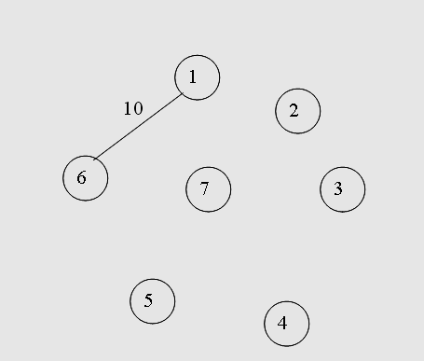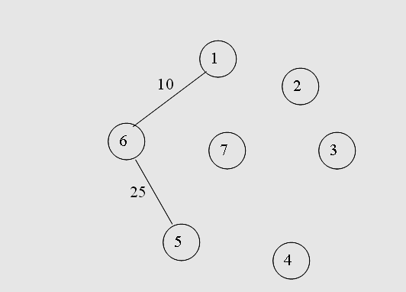
Step 3: Step 4:
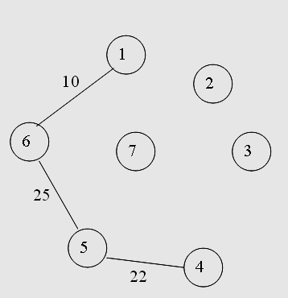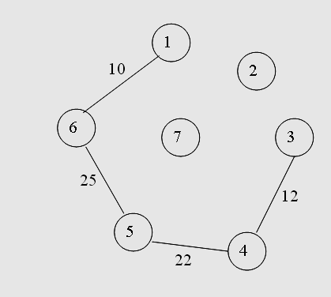
Step 5: Step 6:
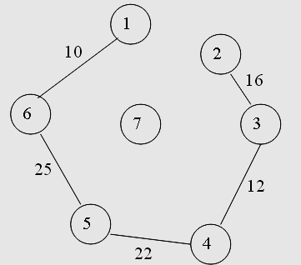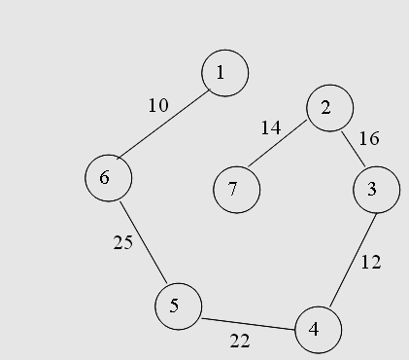
COMPLEXITY
The set t is the set of edges to be included in the minimum – cost spanning tree and i is the number of edges in t. The set t can be represented as a sequential list using a two – dimensional array t [ 1: n – 1, 1 : 2]. Edge (u, v) can be added to t by the assignments t[ i, 1] := u ; and y[ i, 2] := v; . In the while loop of line 10, edges are removed from the heap one by one in non-decreasing order of cost. Line 14 determines the sets containing u and v. If j ≠ k then vertices u and v are in different sets and edge (u, v) is included into t. The sets containing u and v are combined in line 20. If u = v the edge (u, v) is discarded as its inclusions into t would create a cycle. Line 23 determines whether a spanning tree was found. It follows that i ≠ n – 1 iff the graph G is not connected. The computing time is O( | E | log |E|), where e is the edge set of G.
3.2.3 JOB SCHEDULING WITH DEAD LINES
The problem is the number of jobs, their profit and deadlines will be given and we have to find a sequence of job, which will be completed within its deadlines, and it should yield a maximum profit.

Points To remember:
- To complete a job, one has to process the job or a action for one unit of time.
- Only one machine is available for processing jobs.
- A feasible solution for this problem is a subset of j of jobs such that each job in this subject can be completed by this deadline.
- If we select a job at that time ,

→Since one job can be processed in a single m/c. The other job has to be in its waiting state until the job is completed and the machine becomes free.

→So the waiting time and the processing time should be less than or equal to the dead line of the job.

ALGORITHM:
Algorithm JS(d,j,n)
//The job are ordered such that p[1]>p[2]…>p[n]
//j[i] is the ith job in the optimal solution
// Also at terminal d [ J[ i]<=d[ J {i+1],1<i<k
{
d[0]= J[0]=0;
J[1]=1;
K=1;
For I =1 to n do
{ // consider jobs in non increasing order of P[I];find the position for I and check feasibility insertion
r=k;
while((d[J[r]]>d[i] )and
(d[J[r]] = r)do r =r-1;
if (d[J[r]]<d[I])and (d[I]>r))then
{
for q=k to (r+1) step –1 do J [q+1]=j[q]
J[r+1]=i;
K=k+1;
}
}
return k;
}
Example:
- n=5 (P1,P2,…P5)=(20,15,10,5,1)
(d1,d2….d3)=(2,2,1,3,3)

Feasible solution Processing Sequence Value

(1) (1) 20
(2) (2) 15
(3) (3) 10
(4) (4) 5
(5) (5) 1
(1,2) (2,1) 35
(1,3) (3,1) 30
(1,4) (1,4) 25
(1,5) (1,5) 21
(2,3) (3,2) 25
(2,4) (2,4) 20
(2,5) (2,5) 16
(1,2,3) (3,2,1) 45
(1,2,4) (1,2,4) 40

The Solution 13 is optimal

- n=4 (P1,P2,…P4)=(100,10,15,27)
(d1,d2….d4)=(2,1,2,1)
Feasible solution Processing Sequence Value
(1,2) (2,1) 110
(1,3) (1,3) 115
(1,4) (4,1) 127
(2,3) (9,3) 25
(2,4) (4,2) 37
(3,4) (4,3) 42
(1) (1) 100
(2) (2) 10
(3) (3) 15
(4) (4) 27
The solution 3 is optimal.
3.3 DYNAMIC PROGRAMMING
Dynamic programming is an algorithm design method that can be used when the solution to a problem can be viewed as the result of a sequence of decisions. Below are some of the examples of problems that can be viewed this way.
1) KNAPSACK-The solution to the knapsack problem can be viewed as the result of a sequence of decisions. We have to decide the values of x_{i}, 1 ≤ i ≤ n.An optimal sequence of decisions maximizes the objective function ∑p_{i}x_{i}.It also satisfies the constraints ∑w_{i}x_{i}≤m and 0 ≤ x_{i} ≤1.
2) OPTIMAL MERGE PATTERNS-An optimal merge pattern tells us which pair of files should be merged at each step. An optimal sequence of decisions is a least cost sequence.
3) SHORTEST PATH-One way to find a shortest path from vertex i to vertex j in a directed graph G is to decide which vertex should be the second vertex, which the third and so on. An optimal sequence of decisions is one that results in a path of least length.
For some of the problems that may be viewed in this way, an optimal sequence of decisions can be found by making the decisions one at a time and never making an erroneous decision. This is true for all problems solvable by the greedy method. For many problems it is not possible to make stepwise decisions in such a manner that the sequence of decisions made is optimal.
One way to solve problems for which it is not possible to make a sequence of stepwise decisions leading to an optimal decision sequence is to try all possible decision sequences. We could enumerate all decision sequences and then pick out the best. But the time and space requirements may be prohibitive. Dynamic programming often drastically reduces the amount of enumeration by avoiding the enumeration of some decision sequences that cannot possibly be optimal. In dynamic programming an optimal sequence of decisions is obtained by making explicit appeal to the principle of optimality.

PRINCIPLE OF OPTIMALITY
The principle of optimality states that an optimal sequence of decisions has the property that whatever the initial state and decisions are, the remaining decisions must constitute an optimal decision sequence with regard to the state resulting from the first decision.
Thus, the essential difference between the greedy method and dynamic programming is that in the greedy method only one decision sequence is ever generated. In dynamic programming, many decision sequences may be generated. However, sequences containing suboptimal subsequence’s cannot be optimal(if the principle of optimality holds)and so will not be generated as far as possible.
Example: SHORTEST PATH
Consider the shortest path problem. Assume that i,i₁,i₂,.........i_{k},j is a shortest path from i to j. Starting with the initial vertex i,a decision has been made to go to vertex i_{1.}Following this decision the problem state is defined by vertex i₁ and we need to find a path from i₁ to j.It is clear that the sequence i₁,i₂,.......i_{k},j must constitute a shortest i₁ to j path. If not, let i₁,r₁,r₂,........r_{q},j be a shortest i₁ to j path. Then i,i₁,r_{1,}.......,r_{q},j is an i to j path that is shorter than the path i,i₁,i₂,.......,i_{k},j. Therefore the principle of optimality applies for this problem.
Because of the use of principle of optimality, decision sequences containing subsequence’s that are suboptimal are not considered. Although the total number of different decision sequences is exponential in the number of decisions (if there are d choices for each of the n decisions to be made then there are d^{n} possible sequences), dynamic programming algorithms often have a polynomial complexity.
Another important feature of dynamic programming approach is that optimal solutions to sub problems are retained so as to avoid recomputing their values. The uses of these tabulated values make it natural to recast the recursive equations into an iterative algorithm.

3.3.1 MULTISTAGE GRAPHS
EXPLANATION
Theory
A multistage graph G = (V, E) is a directed graph in which the vertices are partitioned into k>=2 disjoint sets Vi, 1<=i<=k. If (u, v) is an edge in E, then u ε Vi and v ε Vi+1 for some i, 1<=i<k. The sets V1 and Vk are such that | V1|=|Vk|=1. Let s and t be the vertex in V1 and Vk. The vertex s is the source, and t the sink. Let c (i,j) be the cost of edge (i, j).The cost of a path from s to t is the sum of the costs of the edges on the path.
The multistage graph problem is to find a minimum-cost path from s to t. Each set Vi defines a stage in the graph. Because of the constraints on E, every path from s to t starts in stage 1, goes to stage 2, then to stage 3, then stage 4, etc., and eventually terminates in stage k.
A dynamic programming formulation for a k-stage graph problem is obtained by using the principle of optimality. According to this principle a path (i, k) is said to be optimal if and only if the intermediate paths (i, j) and (j, k) are also optimal. The multistage graph problem has two approaches namely, forward and backward. In forward approach the resulting path is obtained by moving in the direction of destination from source, even though it appears in reverse. In the latter case it from destination to source tracing the lowest cost path.
Equation
The cost of a path (i, j) is given by the equation
cost (i, j) = min {c (j, l) + cost (i+1, l)}
l ε Vi+1
(j, l) ε E
where j is a vertex in Vi.
Here cost (i, j) means i th level and the cost of edge from j th node to the last node.

EXAMPLE
Consider the following figure. The graph is a 5 stage graph, with 12 vertices and the cost of each node is given. The aim is to find the minimum cost path from the first node to the last node.
Figure
V1 V2 V3 V4 V5

1
2
3
4
5
6
7 77
8
9
10000
11
12
9
7
3
2
4
2
2
7
1
11
11
8
6
5
4
3
5
6
5
2
4

Cost Calculation
cost (4, 9) =4
cost (4,10) =2
cost (4,11) =5
cost (3,6) = cost from 6 th to 12 th node = min { 5+ cost (4, 9),6+ cost (4, 10) }=7
cost (3,7) = min { 4+ cost (4, 9),3+ cost (4, 10) }=5
cost (3,8) = min { 5+ cost (4, 10),6+ cost (4, 11) }=7
cost (2,2) = min { 4+ cost (3, 6),2+ cost (3, 7), 1+ cost (3, 8) }=7
cost (2,3) = min { 2+ cost (3, 6),7+ cost (3, 7)}=9
cost (2,4) = 11+cost (3, 8)=18
cost (2,5) = min { 11+ cost (3, 7),8+ cost (3, 8)}=15
cost (1,1) = min { 9+ cost (2, 2),7+ cost (2,3), 11+ cost (2, 4) ,2+ cost (2, 5)}=16
By selecting the least cost edges from each group we can determine which all edges will be involved in the minimum cost path.
Thus the minimum cost path in forward approach is (1, 2, 7, 10, 12) and in backward approach it is (1, 3, 6, 10, 12).Both have a cost of 16 each.

FORWARD APPROACH
EXPLANATION:
A multistage graph G = (V, E) is a directed graph in which the vertices are partitioned into k>=2 disjoint sets Vi, 1<=i<=k. If (u, v) is an edge in E, then u ε Vi and v ε Vi+1 for some i, 1<=i<k. The sets V1 and Vk are such that | V1|=|Vk|=1. Let s and t be the vertex in V1 and Vk. The vertex s is the source, and t the sink. Let c (i,j) be the cost of edge (i, j).The cost of a path from s to t is the sum of the costs of the edges on the path.
The multistage graph problem is to find a minimum-cost path from s to t. Each set Vi defines a stage in the graph. Because of the constraints on E, every path from s to t starts in stage 1, goes to stage 2, then to stage 3, then stage 4, etc., and eventually terminates in stage k.
A dynamic programming formulation for a k-stage graph problem is obtained by using the principle of optimality. According to this principle a path (i, k) is said to be optimal if and only if the intermediate paths (i, j) and (j, k) are also optimal.
The multistage graph problem has two approaches namely, forward and backward. In forward approach the resulting path is obtained by moving in the direction of destination from source, even though it appears in reverse. In the latter case it from destination to source tracing the lowest cost path.
By using the forward approach, we obtain the cost of a path (i, j) which is given by the following equation:

cost (i, j) = min {c (j, l) + cost (i+1, l)}
l ε Vi+1
(j, l) ε E , where j is a vertex in Vi.

Here cost (i, j) means i ^{th} level and the cost of edge from j th node to the last node. Consider the example given below. This is a 5 stage graph, with 12 vertices and the cost of each node is given. The aim is to find the minimum cost path from the first node to the last node. This can be done by using the forward approach as shown below:

EXAMPLE:

V1 V2 V3 V4 V5
1
2
3
4
5
6
7 77
8
9
10000
11
122
9
7
3
2
4
2
2
7
1
11
11
8
6
5
4
3
5
6
5
2
4

CALCULATING THE MINIMUM COST:
cost (4, 9) = cost from 4th node to the 9th node = 4
cost (4,10) = 2
cost (4,11) =5
cost (3,6) = min { 6+ cost (4, 9), 6+ cost (4, 10) }= 7
cost (3,7) = min { 4+ cost (4, 9), 3+ cost (4, 10) }= 5
cost (3,8) = min { 5+ cost (4, 10), 6+ cost (4, 11) }= 7
cost (2,2) = min { 4+ cost (3, 6), 2+ cost (3, 7), 1+ cost (3, 8) }= 7

While calculating the value of cost (2,2) the values of cost (3,6), cost (3,7) and cost (3,8) have been reused so as to avoid their re-computation.
cost (2,3) = min { 2+ cost (3, 6), 7+ cost (3, 7)}= 9
cost (2,4) = min{11+cost (3, 8)}= 18
cost (2,5) = min { 11+ cost (3, 7), 8+ cost (3, 8)}= 15
cost (1,1) = min { 9+ cost (2, 2), 7+ cost (2,3), 11+ cost (2, 4) , 2+ cost (2, 5)}= 16
A minimum costs to t path has a cost of 16.
Thus, the cost of forward approach is= 16.
By selecting the least cost edges from each group we can determine which all edges will be involved in the minimum cost path.
Thus the minimum cost path in forward approach is (1, 2, 7, 10, 12) which has the cost of 16. It is represented using dotted lines.
This is the multistage graph forward approach problem.

BACKWARD APPROACH:
The Multistage graph problem can be solved using backward approach in the following manner. Let bp(i,j) be a minimum-cost path from vertex s to a vertex j in V_{i} . let bcost(i,j) be the cost of bp(i,j). From the backward approach we obtain

bcost(i,j) = min {bcost(i-1,l) + c(l,j)}
l Є V_{i-1}
<l,j> Є E

Algorithm in psedocode corresponding to obtain a minimum-cost s-t graph is BGraph.(Algorithm 1.1) The first subscript on bcost, p and d are omitted for the same reasons as before. This algorithm has the same complexity as FGraph provided G is now represented by itsinverse adjacency lists (i.e., for each vertex v we have a list of vertices w such that <w,v> Є E

ALGORITHM
- Algorithm BGraph(G,k,n,p)
- // Same function as FGraph
- {
- bcost[1] :=0.0; <r,j>
- for j :=2 to n do
- { / / Compute bcost[j].
- Let r be such that is an edge of G is an edge of and bcost is an edge of
- G and bcost[r] + c[r,j] is minimum;
- bcost[j] :=bcost[r] + c[r,j];
- d[j] := r;
- }
- / / Find a minimum-cost path.
- p[1] := 1; p[k] :=n;
- for j := k – 1 to 2 do p[j] := d[p[j+1]];
- }

It should be easy to see that both FGraph and BGraph work correctly even on a more generalized version of multistage graphs. In this generalization, the graph is permitted to have edges <u,v> such that u Є V_{i} , v Є V_{j} and i< j.
In the pseudocodes FGraph and BGraph, bcost(i,j) is set to ∞ for any <i,j> Є E. When programming these pseudocodes, one could use the maximum allowable floating point number for ∞. If the weight of any such edge is added to some other costs, a floatin point overflow might occur. Care should be taken to avoid such overflows.

Eg:
- d(B, T) = min{9+d(D, T), 5+d(E, T), 16+d(F, T)}
= min{9+18, 5+13, 16+2} = 18.
- d(C, T) = min{ 2+d(F, T) } = 2+2 = 4
- d(S, T) = min{1+d(A, T), 2+d(B, T), 5+d(C, T)}
= min{1+22, 2+18, 5+4} = 9.
- The above way of reasoning is called backward reasoning.

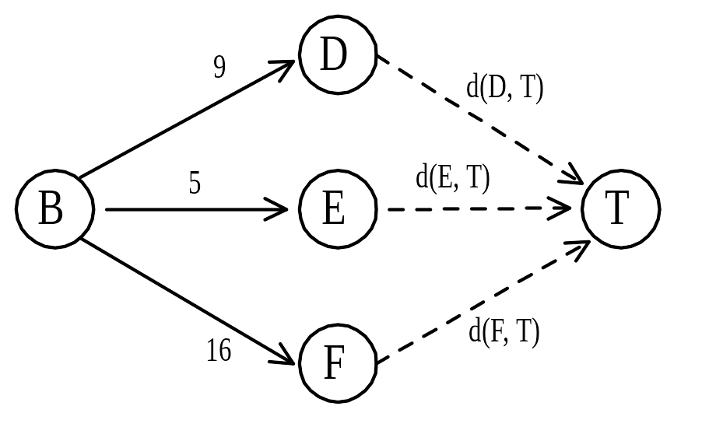

Backward approach
(forward reasoning)
- d(S, A) = 1
d(S, B) = 2
d(S, C) = 5
- d(S,D)=min{d(S, A)+d(A, D),d(S, B)+d(B, D)}
= min{ 1+4, 2+9 } = 5
d(S,E)=min{d(S, A)+d(A, E),d(S, B)+d(B, E)}
= min{ 1+11, 2+5 } = 7
d(S,F)=min{d(S, A)+d(A, F),d(S, B)+d(B, F)}
= min{ 2+16, 5+2 } = 7
- d(S,T) = min{d(S, D)+d(D, T),d(S,E)+d(E,T), d(S, F)+d(F, T)}
= min { 5+18, 7+13, 7+2 }
= 9
- Forward approach and backward approach:
  - Note that if the recurrence relations are formulated using the forward approach then the relations are solved backwards. i.e., beginning with the last decision
  - On the other hand if the relations are formulated using the backward approach, they are solved forwards.

3.3.2 ALL PAIRS SHORTEST PATH
Finding all pairs shortest path consists of finding the shortest distance between every pair of nodes in a possibly directed graph. Various means of doing so are known, and the following list gives a few of the common methods:
- Floyd-Warshall algorithm is an elegant, quickly implementable O(n³) algorithm (Assumes absence of negatively-weighed cycles).
- Johnson's algorithm is harder to implement, but might perform better for sparse graphs.
- Algorithms for single source problem might also be repeatedly used, although they often perform worse or are harder to optimize
FLOYD-WARSHELL ALGORITHM
In computer science, the Floyd–Warshall algorithm (sometimes known as the WFI Algorithm or Roy–Floyd algorithm, since Bernard Roy described this algorithm in 1959) is a graph analysis algorithm for finding shortest paths in a weighted, directed graph. A single execution of the algorithm will find the shortest paths between all pairs of vertices. The Floyd–Warshall algorithm is an example of dynamic programming

Algorithm
The Floyd-Warshall algorithm compares all possible paths through the graph between each pair of vertices. It is able to do this with only V³ comparisons. This is remarkable considering that there may be up to V² edges in the graph, and every combination of edges is tested. It does so by incrementally improving an estimate on the shortest path between two vertices, until the estimate is known to be optimal.
Consider a graph G with vertices V, each numbered 1 through N. Further consider a function shortestPath(i,j,k) that returns the shortest possible path from i to j using only vertices 1 through k as intermediate points along the way. Now, given this function, our goal is to find the shortest path from each i to each j using only nodes 1 through k + 1.
There are two candidates for this path: either the true shortest path only uses nodes in the set (1...k); or there exists some path that goes from i to k + 1, then from k + 1 to j that is better. We know that the best path from i to j that only uses nodes 1 through k is defined by shortestPath(i,j,k), and it is clear that if there were a better path from i to k + 1 to j, then the length of this path would be the concatenation of the shortest path from i to k + 1 (using vertices in (1...k)) and the shortest path from k + 1 to j (also using vertices in (1...k)).
Therefore, we can define shortestPath(i,j,k) in terms of the following recursive formula
This formula is the heart of Floyd Warshall. The algorithm works by first computing shortestPath(i,j,1) for all (i,j) pairs, then using that to find shortestPath(i,j,2) for all (i,j) pairs, etc. This process continues until k=n, and we have found the shortest path for all (i,j) pairs using any intermediate vertices.

Pseudocode
Conveniently, when calculating the kth case, one can overwrite the information saved from the computation of k − 1. This means the algorithm uses quadratic memory. Be careful to note the initialization conditions:
1 /* Assume a function edgeCost(i,j) which returns the cost of the edge from i to j
2 (infinity if there is none).
3 Also assume that n is the number of vertices and edgeCost(i,i)=0
4 */
5
6 int path[][];
7 /* A 2-dimensional matrix. At each step in the algorithm, path[i][j] is the shortest path
8 from i to j using intermediate vertices (1..k-1). Each path[i][j] is initialized to
9 edgeCost(i,j) or infinity if there is no edge between i and j.
10 */
11
12 procedure FloydWarshall ()
13 for k: = 1 to n
14 for each (i,j) in {1,..,n}²
15 path[i][j] = min ( path[i][j], path[i][k]+path[k][j] );

Analysis
To find all n² of from those of requires 2n² bit operations. Since we begin with and compute the sequence of n zero-one matrices , , ..., , the total number of bit operations used is . Therefore, the complexity of the algorithm is Θ(n³) and can be solved by a deterministic machine in polynomial time
Applications and generalizations
The Floyd–Warshall algorithm can be used to solve the following problems, among others:
- Shortest paths in directed graphs (Floyd's algorithm).
- Transitive closure of directed graphs (Warshall's algorithm). In Warshall's original formulation of the algorithm, the graph is unweighted and represented by a Boolean adjacency matrix. Then the addition operation is replaced by logical conjunction (AND) and the minimum operation by logical disjunction (OR).
- Finding a regular expression denoting the regular language accepted by a finite automaton (Kleene's algorithm)
- Inversion of real matrices (Gauss-Jordan algorithm).
- Optimal routing. In this application one is interested in finding the path with the maximum flow between two vertices. This means that, rather than taking minima as in the pseudocode above, one instead takes maxima. The edge weights represent fixed constraints on flow. Path weights represent bottlenecks; so the addition operation above is replaced by the minimum operation.
- Testing whether an undirected graph is bipartite.
- Fast computation of Pathfinder Networks.
- Maximum Bandwidth Paths in Flow Networks
3.3.3 TRAVELLING SALESMAN PROBLEM
- Let G(V,E) be a directed graph with edge cost c_{ij} is defined such that c_{ij} >0 for all i and j and c_{ij} =∝ ,if <i,j> ∉ E.
Let V =n and assume n>1.
- The traveling salesman problem is to find a tour of minimum cost.
- A tour of G is a directed cycle that include every vertex in V.
- The cost of the tour is the sum of cost of the edges on the tour.
- The tour is the shortest path that starts and ends at the same vertex (ie) 1.

APPLICATION:
- Suppose we have to route a postal van to pick up mail from the mail boxes located at ‘n’ different sites.
- An n+1 vertex graph can be used to represent the situation.
- One vertex represents the post office from which the postal van starts and returns.
- Edge <i,j> is assigned a cost equal to the distance from site ‘i’ to site ‘j’.
- The route taken by the postal van is a tour and we are finding a tour of minimum length.
- every tour consists of an edge <1,k> for some k ∈ V-{} and a path from vertex k to vertex 1.
- The path from vertex k to vertex 1 goes through each vertex in V-{1,k} exactly once.
- the function which is used to find the path is
g(1,V-{1}) = min{ c_{ij} + g(j,s-{j})}
- g(i,s) be the length of a shortest path starting at vertex i, going through all vertices in S,and terminating at vertex 1.
10. The function g(1,v-{1}) is the length of an optimal tour.
STEPS TO FIND THE PATH:
- Find g(i,Φ) =c_{i1}, 1<=i<n, hence we can use equation(2) to obtain g(i,s) for all s to size 1.
- That we have to start with s=1,(ie) there will be only one vertex in set ‘s’.
- Then s=2, and we have to proceed until |s| <n-1.
- for example consider the graph.
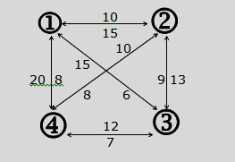
Cost matrix
0 10 15 20
5 0 9 10
6 13 0 12
8 8 9 0
g(i,s) set of nodes/vertex have to visited.

starting position
g(i,s) =min{c_{ij} +g(j,s-{j})
STEP 1:
g(1,{2,3,4})=min{c₁₂+g(2{3,4}),c₁₃+g(3,{2,4}),c₁₄+g(4,{2,3})}
min{10+25,15+25,20+23}
min{35,35,43}
=35
STEP 2:
g(2,{3,4}) = min{c₂₃+g(3{4}),c₂₄+g(4,{3})}
min{9+20,10+15}
min{29,25}
=25

g(3,{2,4}) =min{c₃₂+g(2{4}),c₃₄+g(4,{2})}
min{13+18,12+13}
min{31,25}
=25

g(4,{2,3}) = min{c₄₂+g(2{3}),c₄₃+g(3,{2})}
min{8+15,9+18}
min{23,27}
=23
STEP 3:
- g(3,{4}) = min{c₃₄ +g{4,Φ}}
12+8 =20
- g(4,{3}) = min{c₄₃ +g{3,Φ}}
9+6 =15
- g(2,{4}) = min{c₂₄ +g{4,Φ}}
10+8 =18

- g(4,{2}) = min{c₄₂ +g{2,Φ}}
8+5 =13

- g(2,{3}) = min{c₂₃ +g{3,Φ}}
9+6=15
- g(3,{2}) = min{c₃₂ +g{2,Φ}}
13+5=18

STEP 4:

g{4,Φ} =c₄₁ = 8
g{3,Φ} =c₃₁ = 6
g{2,Φ} =c₂₁ = 5

s = 0.

i =1 to n.
g(1,Φ) = c₁₁ => 0
g(2,Φ) = c₂₁ => 5
g(3,Φ) = c₃₁ => 6
g(4,Φ) = c₄₁ => 8

s = 1

i =2 to 4
g(2,{3}) = c₂₃ + g(3,Φ)
= 9+6 =15
g(2,{4}) = c₂₄ + g(4,Φ)
= 10+8 =18
g(3,{2}) = c₃₂ + g(2,Φ)
= 13+5 =18
g(3,{4}) = c₃₄ + g(4,Φ)
= 12+8 =20
g(4,{2}) = c₄₂ + g(2,Φ)
= 8+5 =13
g(4,{3}) = c₄₃ + g(3,Φ)
= 9+6 =15

s = 2

i ≠ 1, 1∈ s and i ∈ s.

g(2,{3,4}) = min{c₂₃+g(3{4}),c₂₄+g(4,{3})}
min{9+20,10+15}
min{29,25}
=25

g(3,{2,4}) =min{c₃₂+g(2{4}),c₃₄+g(4,{2})}
min{13+18,12+13}
min{31,25}
=25

g(4,{2,3}) = min{c₄₂+g(2{3}),c₄₃+g(3,{2})}
min{8+15,9+18}
min{23,27}
=23
s = 3

g(1,{2,3,4})=min{c₁₂+g(2{3,4}),c₁₃+g(3,{2,4}),c₁₄+g(4,{2,3})}
min{10+25,15+25,20+23}
min{35,35,43}
=35
optimal cost is 35
The shortest path is,
g(1,{2,3,4}) = c₁₂ + g(2,{3,4}) => 1->2
g(2,{3,4}) = c₂₄ + g(4,{3}) => 1->2->4
g(4,{3}) = c₄₃ + g(3{Φ}) => 1->2->4->3->1
so the optimal tour is 1 → 2 → 4 →3 → 1

